AI Career Companion Agent for Internship Matching and Interview Preparation

Agile Project Documentation

Prepared By:
Manisha Choudhary

Project Duration:
22 July 2026 - 22 September 2026

Mentor:
Vijay Parmar

Technology:
React | FastAPI | PostgreSQL | Groq

INDEX
Sr.No | Topics | Pg.No
1 | Project Overview | 3
2 | Project Objective | 4
3 | Technology Stack | 5
4 | Project Requirements | 6-7
5 | System Architecture / Workflow | 8
6 | Product Backlog | 9
7 | Sprint Planning | 10
8 | Sprint Tasks & Status | 11
9 | Implementation / Key Features | 12-14
10 | Testing | 15
11 | Challenges & Solutions | 16
12 | Final Project Status | 17-18

AI Career Companion Agent for Internship Matching and Interview Preparation

AI Career Pilot is a full-stack AI-powered career assistance platform designed primarily for college students and internship seekers.
The application combines resume analysis, internship discovery, personalized internship matching, application tracking, cover-letter generation, career assistance and interview preparation into a single platform.
Users can create an account, maintain their career profile and upload their resume in PDF or DOCX format. The system extracts and analyzes information from the resume and uses it to provide relevant internship recommendations.
The application also provides an AI Career Assistant and a separate Interview Preparation Agent. The Interview Preparation Agent can use the user's parsed resume and an optional uploaded document to provide personalized technical, HR, role-specific and career-related guidance.

Problem Statement

Students generally use multiple platforms and tools for different stages of their career journey.
For example:
- One platform may be used for finding internships.
- Another may be used for resume analysis.
- Another may be used for interview preparation.
- Students may manually compare their skills with internship requirements.
- Generic internship recommendations may not explain why a particular internship is suitable.
This creates a fragmented career-preparation process.
The proposed system solves this problem by combining these activities into one platform and using the user's resume and career information to provide personalized recommendations and assistance.

Target Users

The primary target users are:
- College students
- Internship seekers
- Recent graduates
- Students preparing for technical interviews
- Students preparing for HR interviews
- Students looking for personalized career guidance

PROJECT OBJECTIVE

The main objective of the project is to develop an AI-assisted career platform that helps students manage their internship journey and prepare for interviews using their own resume and career information.

Objectives:

- Implement secure user registration and login.
- Provide JWT-based authentication for protected operations.
- Allow users to create and maintain their career profiles.
- Allow users to upload PDF and DOCX resumes.
- Extract text from uploaded resumes.
- Convert unstructured resume information into structured data.
- Use AI to improve contextual resume analysis.
- Retrieve relevant internship opportunities using semantic similarity.
- Calculate internship compatibility using candidate information.
- Display matched and missing skills.
- Provide internship recommendations based on candidate profiles.
- Allow users to save and apply to internships.
- Track internship application status.
- Generate personalized cover letters.
- Provide an AI Career Assistant for application-related guidance.
- Provide a separate Interview Preparation Agent.
- Allow the Interview Preparation Agent to use resume and uploaded document context.
- Store user and application data using PostgreSQL.
- Maintain conversation history for AI-based features.
- Test important backend and matching functionality.

Expected Outcome

The expected outcome is a single career-support platform where a student can upload their resume, discover suitable internship opportunities, understand their compatibility with those opportunities, manage applications and receive personalized AI assistance for career and interview preparation.

TECHNOLOGY STACK

Category | Technology | Purpose
Frontend | React 18 | User interface
Frontend Build Tool | Vite | Frontend development and build
Navigation | React Router | Client-side navigation
Backend | Python | Backend programming
API Framework | FastAPI | REST API development
Server | Uvicorn | Running the FastAPI application
Database | PostgreSQL | Persistent data storage
ORM | SQLAlchemy | Database interaction
Validation | Pydantic | Request and response validation
Authentication | JWT / python-jose | User authentication
Password Security | Passlib / bcrypt | Password hashing
LLM | Groq | AI-powered processing and responses
AI Framework | LangChain | LLM integration
Embeddings | Sentence Transformers | Semantic representation
Vector Search | FAISS | Semantic retrieval
Document Processing | PyMuPDF | PDF text extraction
Document Processing | python-docx | DOCX text extraction
Reliability | Tenacity | Retry handling for AI operations
Database Migration | Alembic | Database schema migrations
Version Control | Git / GitHub | Source-code management

Technology Selection

The project currently uses Groq for LLM functionality and FAISS with Sentence Transformers for semantic retrieval.
These technologies are documented according to the current implementation rather than generic alternatives such as Gemini or ChromaDB.

PROJECT REQUIREMENTS

Functional Requirements

User Authentication
- User should be able to register.
- User should be able to log in.
- User should be able to log out.
- Protected resources should require authentication.
- Password-related operations should be validated.

Career Profile
The user should be able to maintain information such as:
- Personal details
- Education
- Skills
- Experience
- Projects
- Career-related information

Resume Management
The system should:
- Accept PDF resumes.
- Accept DOCX resumes.
- Extract resume text.
- Parse important resume information.
- Store parsed resume information.
- Allow the parsed information to be used by other features.

Internship Matching
The system should:
- Retrieve internship opportunities.
- Compare internship requirements with candidate information.
- Use semantic retrieval.
- Calculate compatibility.
- Show matched skills.
- Show missing skills.
- Provide understandable matching results.

Application Management
Users should be able to:
- View internship opportunities.
- Apply to opportunities.
- Track application status.

AI Career Assistant
The assistant should:
- Answer career-related questions.
- Use relevant product knowledge.
- Maintain conversation context.
- Store chat history.

Interview Preparation Agent
The Interview Preparation Agent should:
- Use the user's parsed resume.
- Accept an optional PDF/DOCX document.
- Answer technical interview questions.
- Help with HR/behavioral preparation.
- Provide role-specific preparation.
- Help prepare questions about projects and experience.
- Provide learning-roadmap guidance.

Non-Functional Requirements
- Security
- Data privacy
- Good response time
- Error handling
- Maintainable architecture
- Persistent database storage
- Explainable internship matching
- Modular backend services
- User-friendly interface

SYSTEM ARCHITECTURE / WORKFLOW

System Architecture

- Frontend: React + Vite
- Backend: FastAPI + Uvicorn
- Database: PostgreSQL
- AI Layer: Groq + LangChain
- Retrieval: Sentence Transformers + FAISS
- Document Processing: PyMuPDF + python-docx

Workflow

User → React Frontend → FastAPI Backend → Resume/Profile Processing → FAISS Internship Retrieval → Matching & Recommendation → Groq AI Assistance → Response to User

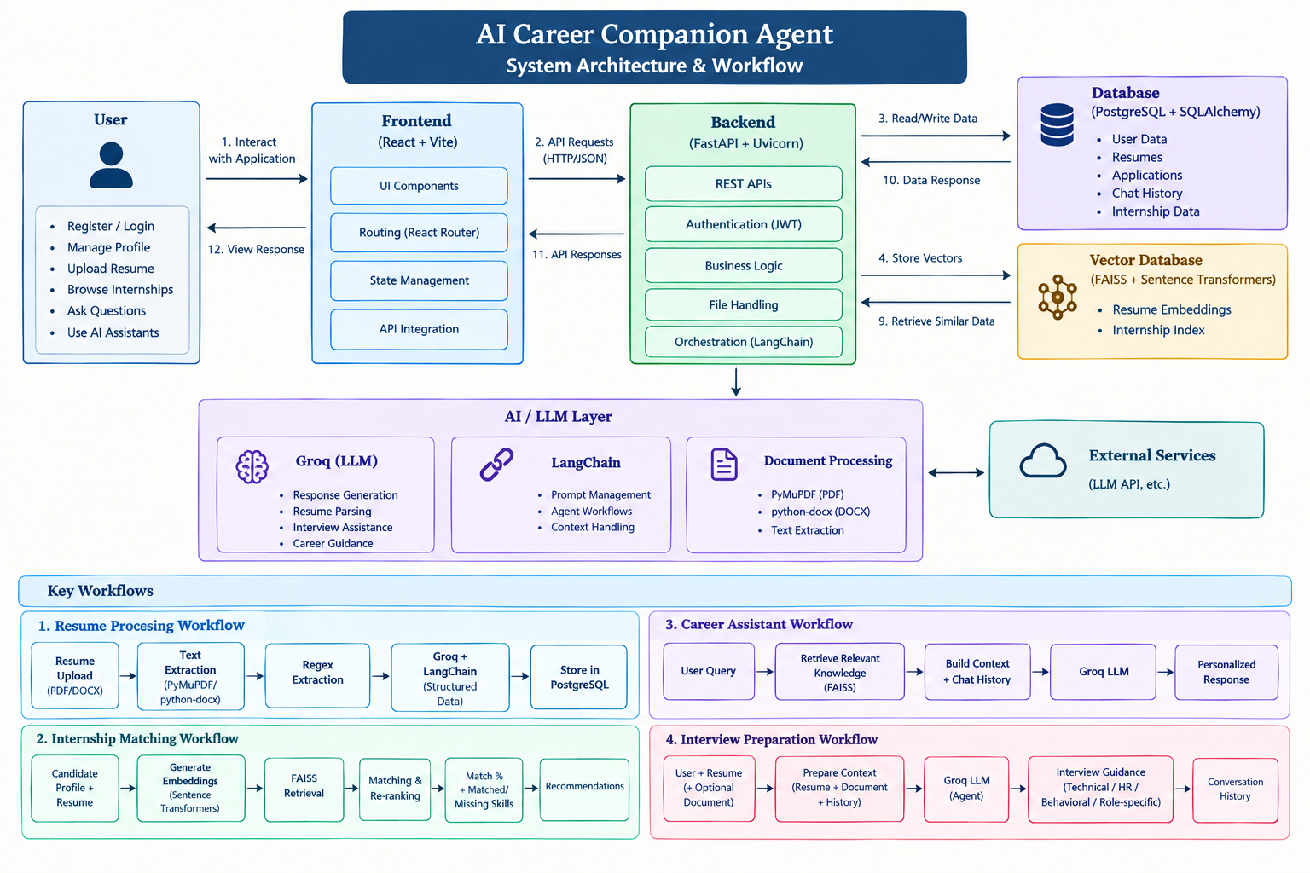

PRODUCT BACKLOG

ID | Feature / Task | Priority | Status
P001 | Project setup and environment | High | Done
P002 | PostgreSQL database setup | High | Done
P003 | SQLAlchemy models | High | Done
P004 | User authentication | High | Done
P005 | JWT protected APIs | High | Done
P006 | Career profile | High | Done
P007 | Resume upload | High | Done
P008 | PDF/DOCX extraction | High | Done
P009 | Resume parsing | High | Done
P010 | FAISS internship retrieval | High | Done
P011 | Internship matching | High | Done
P012 | Matched/missing skill analysis | High | Done
P013 |  | High | Done
  Internship recommendations
P014 | Application tracking | Medium | Done
P015 | Cover-letter generation | Medium | Done
P016 | AI Career Assistant | High | Done
P017 | Product knowledge retrieval | High | Done
P018 | Interview Preparation Agent | High | Done
P019 | Interview document upload | Medium | Done
P020 |  | High | Done
  Automated testing

Priority Levels
- High — Essential functionality
- Medium — Important supporting functionality
- Low — Optional enhancement

Status Levels
To Do → In Progress → Testing → Done

SPRINT PLANNING

Sprint | Main Focus | Major Activities
Sprint 1 | Project Setup & Authentication | Project setup, frontend/backend configuration, PostgreSQL setup, database models, user registration, login and JWT authentication
Sprint 2 | Resume & Internship Matching | Resume upload, PDF/DOCX extraction, resume parsing, internship database, FAISS indexing, internship matching and skill-gap analysis
Sprint 3 | Career Features & AI Assistance | Internship recommendations, application tracking, cover letters, AI Career Assistant and product knowledge retrieval
Sprint 4 | Interview Preparation & Testing | Interview Preparation Agent, resume/document-based interview assistance, conversation history, API testing, matching tests and final integration

Sprint Goals :

Sprint 1 — Foundation
Build the basic application structure, database and secure authentication.

Sprint 2 — Resume Intelligence & Matching
Develop resume processing and the internship matching system.

Sprint 3 — Career Assistance
Implement internship-management features and the AI Career Assistant.

Sprint 4 — Interview Preparation & Finalization
Complete the Interview Preparation Agent, integrate all modules and perform testing.

SPRINT TASKS & STATUS

Sprint | Task | Status
Sprint 1 | Project structure and environment | Done
 | React/Vite frontend setup | Done
 | FastAPI backend setup | Done
 | PostgreSQL database | Done
 | Database models | Done
 | User registration/login | Done
 | JWT authentication | Done
Sprint 2 | Resume upload | Done
 | PDF/DOCX extraction | Done
 | Resume parsing | Done
 | Sentence Transformer embeddings | Done
 | FAISS internship index | Done
 | Internship matching | Done
 | Matched/missing skill analysis | Done
Sprint 3 | Internship recommendations | Done
 | Application tracking | Done
 | Cover-letter generation | Done
 | AI Career Assistant | Done
 | Product knowledge retrieval | Done
 | Chat history | Done
Sprint 4 | Interview Preparation Agent | Done
 | Resume-based interview preparation | Done
 | Optional document context | Done
 | Interview conversation history | Done
 | Backend/API testing | Done
 | Matching scenario testing | Done
 | Final integration | Done

Kanban Workflow:
To Do → In Progress → Testing → Done
IMPLEMENTATION / KEY FEATURES

Feature 1: User Authentication and Profile

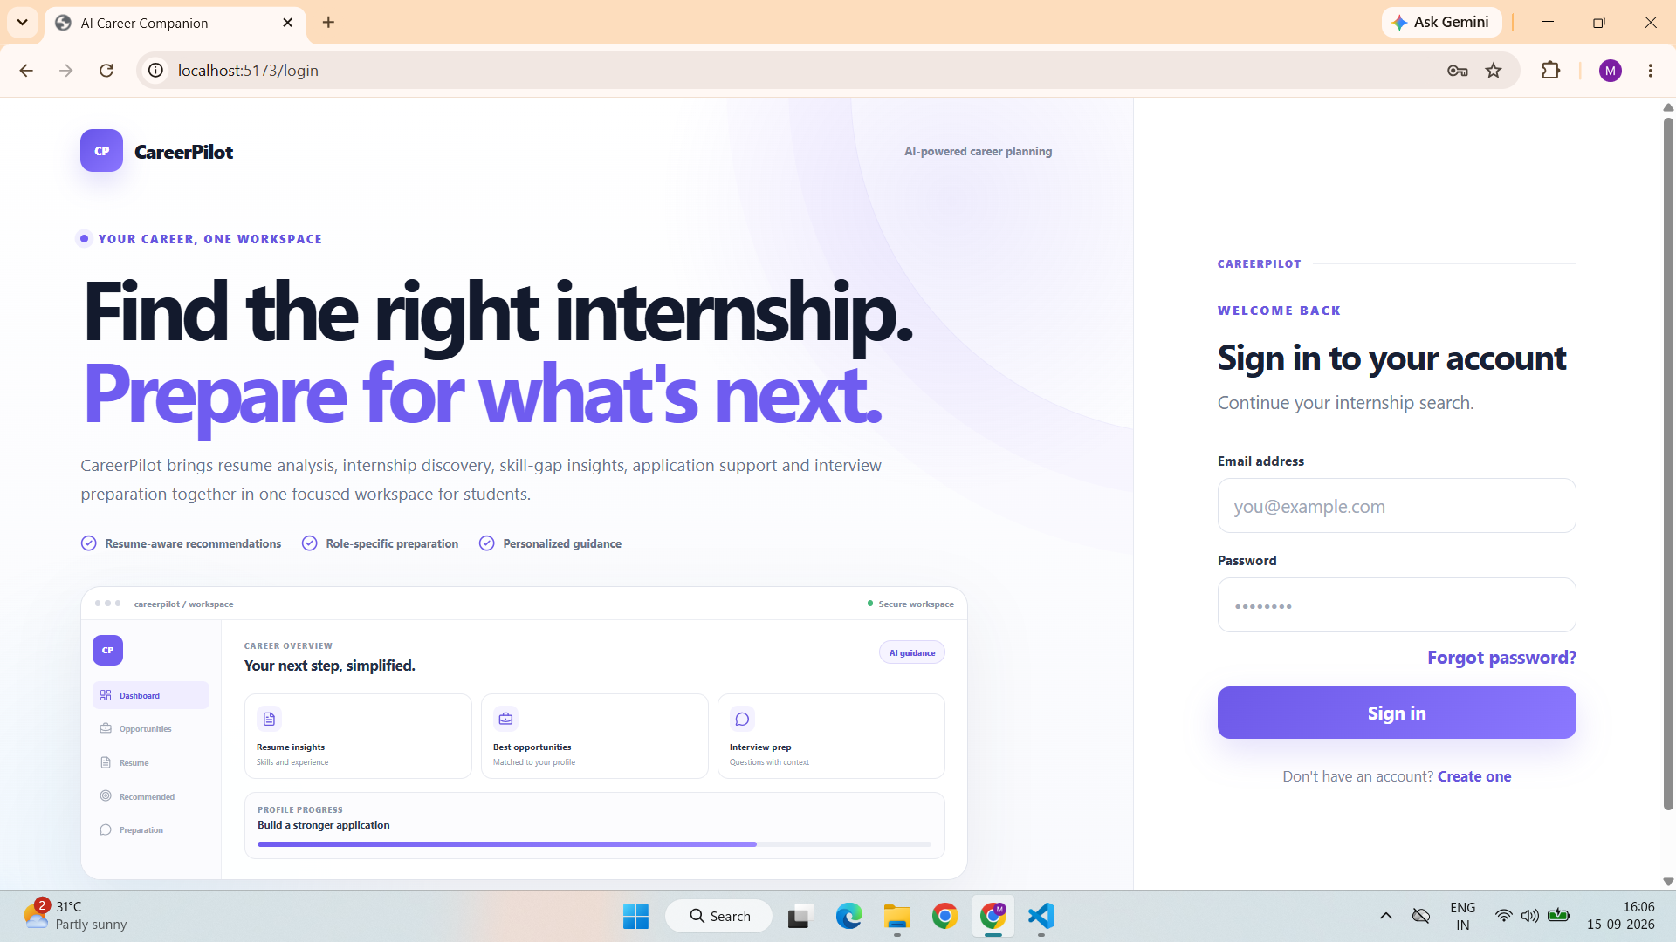

Figure 1: User Login Interface

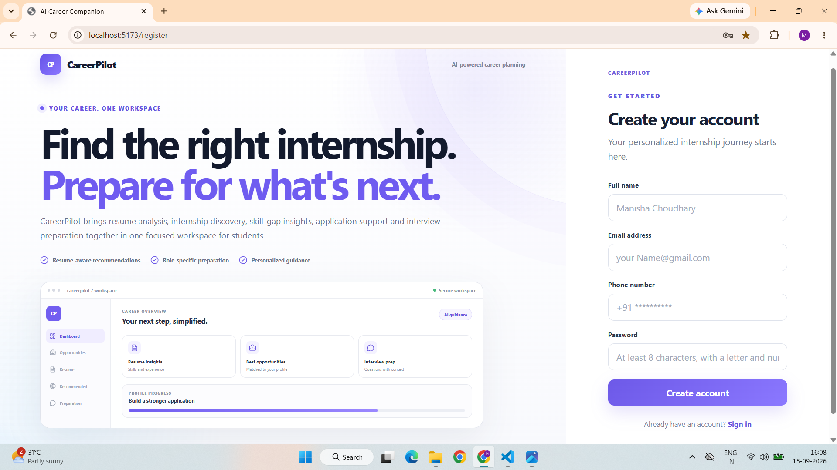

Figure 2: User Registration Interface

The system provides user registration, login and protected API access.
Implementation
JWT authentication is used for protected endpoints. Passwords are securely hashed rather than stored as plain text.
Users can maintain their career profile separately from authentication information.
Result
Users can securely access their own career data and application information.
Screenshot to add: Login / Signup page.

Feature 2: Resume Upload and Parsing

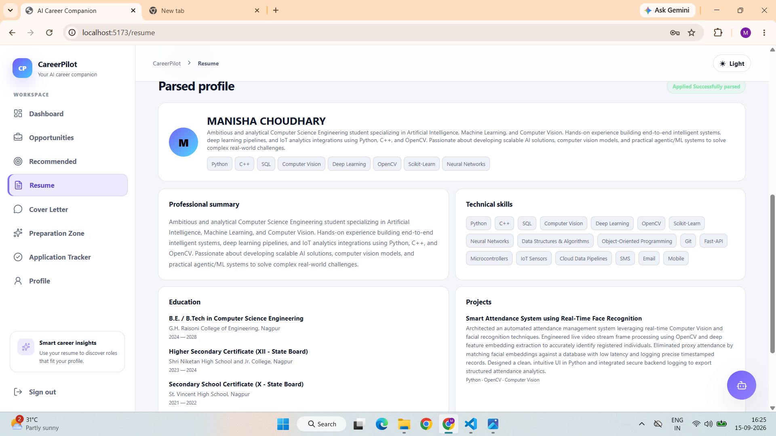

Figure 3 : Resume parsing Interface

Users can upload their resume in PDF or DOCX format.
Implementation
The system extracts text using:
- PyMuPDF for PDF files
- python-docx for DOCX files
The extracted information is processed using a hybrid approach involving Regex and Groq/LangChain.
Result
The system converts an unstructured resume into structured information such as:
- Skills
- Education
- Experience
- Projects
- Internships
- Certifications
- Summary

Feature 3: AI Chatbot

- Provides an AI-powered conversational assistant for career and internship-related queries.
- Uses Groq LLM with LangChain for generating contextual responses.
- Retrieves relevant information from the product knowledge base using FAISS.
- Maintains conversation context through stored chat sessions and messages.
- Helps users with career guidance, internship-related questions, resume-related assistance, and preparation guidance.
- Provides personalized responses instead of fixed or predefined answers.

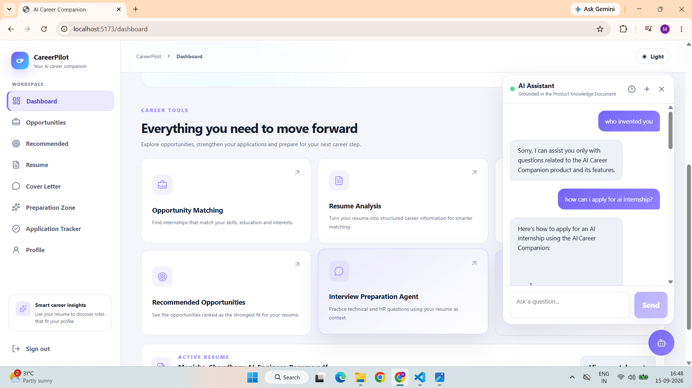

Figure 4: AI Chatbot Interface

TESTING

Automated Backend Testing
The repository contains an automated backend testing suite documented with 8/8 tests passing against PostgreSQL.

Test ID | Test Case | Expected Result | Status
T001 | Valid registration/login | User authenticated successfully | Pass
T002 | Duplicate email registration | Registration rejected | Pass
T003 | Wrong password login | Unauthorized response | Pass
T004 | Access protected route without authentication | Access rejected | Pass
T005 | Password confirmation mismatch | Validation error | Pass
T006 | Cross-user resume access | Unauthorized access prevented | Pass
T007 | Database health endpoint | Database connectivity verified | Pass
T008 | Internship listing/search | Internship data returned | Pass

Testing Types

Functional Testing
Individual application features were checked against their expected behavior.
API Testing
Backend endpoints were tested for:
- Successful requests
- Validation errors
- Authentication failures
- Protected resources
Database Testing
Database health and persistent data operations were tested using PostgreSQL.
Authorization Testing
Cross-user resource access was tested to ensure users cannot access another user's resume data.
CHALLENGES & SOLUTIONS

Challenge 1: Different Resume Formats
- Resumes can have different layouts and structures.
- PDF and DOCX files require different extraction methods.
Solution: Used PyMuPDF and python-docx for document extraction.
- Used a hybrid Regex + AI-based parsing approach.

Challenge 2: Inconsistent AI Output
- LLM responses may vary for different resumes.
- Unstructured AI responses are difficult to store and process.
Solution: Used structured prompts and JSON-based processing.
- Added retry handling for AI requests.

Challenge 3: Keyword-Based Matching Limitations
- Simple keyword matching may fail to identify similar skills or concepts.
Solution: Used Sentence Transformers to generate semantic embeddings.
- Used FAISS for efficient similarity-based internship retrieval.

Challenge 4: Understanding the Match Score
- A percentage alone does not explain why an internship matches.
Solution: The system displays:
  - Match percentage
  - Match category
  - Matched skills
  - Missing skills

Challenge 5: Maintaining Conversation Context
- AI assistants need previous conversation information to provide meaningful responses.
Solution: Implemented chat sessions and stored conversation messages in the database.

Challenge 6: Separating Career Assistance and Interview Preparation
- General career questions and interview preparation require different contexts.
Solution: Implemented the AI Career Assistant and Interview Preparation Agent as separate workflows.

FINAL PROJECT STATUS

Completed Features:

Core AI Features
- Resume parsing
- Semantic internship retrieval
- Internship compatibility matching
- Skill-gap analysis
- AI Career Assistant
- Interview Preparation Agent

Core Application Features
- Authentication
- Profile management
- Application tracking
- Cover-letter generation
- PostgreSQL persistence

Current / Environment-Dependent
- AI-powered features require a valid Groq API configuration.
- Complete local execution requires correct PostgreSQL and frontend/backend environment configuration.
- Production deployment and monitoring can be implemented as a future phase.

Final Outcome
The AI Career Companion Agent successfully implements a full-stack career-support platform that combines resume intelligence, internship matching, application management, AI career assistance and interview preparation.
The system allows students to upload their resume, extract meaningful career information, discover relevant internship opportunities, understand their compatibility with those opportunities, manage applications and receive personalized AI-based interview and career guidance.
The project uses deterministic backend logic for important application operations such as authentication, database persistence and matching calculations, while AI is used for contextual resume understanding, natural-language assistance and interview preparation.
Conclusion
The project demonstrates a practical application of Artificial Intelligence in the student career domain.
Instead of providing only a generic internship listing system, the application uses the student's own resume and career information to provide more personalized assistance throughout the internship journey.
The project also demonstrates the integration of modern technologies including React, FastAPI, PostgreSQL, Groq, LangChain, Sentence Transformers and FAISS into a complete full-stack application.

Future Scope
Future improvements can include:
- Integration of additional verified internship sources.
- Automatic and scheduled internship-data updates.
- Improved matching using real application outcomes and user feedback.
- Advanced interview performance scoring.
- Interview preparation analytics.
- Production deployment and monitoring.
- Rate limiting and stronger production security.
- More advanced document-grounded responses.
- Role-specific learning resources.
- Personalized learning-progress tracking.

